***INDEX***

|  |  |  |  |  |
| --- | --- | --- | --- | --- |
| **S.No** | **Experiment Name** | **Date of Allocation** | **Date of Submission** | **Signature** |
| 1. | Know your devices |  |  |  |
| 2. | To Configure initial Switch Settings |  |  |  |
| 3. | To implement basic connectivity |  |  |  |
| 4. | Basic switch and end device configuration |  |  |  |
| 5. | To connect the physical layer |  |  |  |
| 6. | To examine ARP Table. |  |  |  |
| 7. | To View Network Device MAC Addresses. |  |  |  |
| 8. | To View the Switch MAC Address Table. |  |  |  |
| 9. | To perform basic and initial router configuration |  |  |  |
| 10. | To connect a router to a LAN |  |  |  |
| 11 | Understand Subnetting scenario |  |  |  |
| 12 | Study VLSM design and implementation |  |  |  |
| 13 | Implement subnetted IPv6 addressing scheme |  |  |  |
|  |  |  |  |  |
|  |  |  |  |  |
|  |  |  |  |  |
|  |  |  |  |  |

**EXPERIMENT-1**

**Aim**:

Know your devices.

**Theory:**

* **Cables: -**

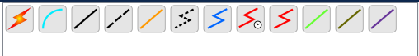

* **Straight Cable:**

A straight through cable is a type of twisted pair cable that is used in local area networks to connect a computer to a network hub such as a router. This type of cable is also sometimes called a patch cable and is an alternative to wireless connections where one or more computers access a router through a wireless signal.

* **Crossover Cable:**

The wire at pin 1 on one end of the cable connects to pin 3 at the other end of the cable. The wire at pin 2 connects to pin 6 on the other end of the cable. Remaining wires connect in the same positions at both ends.

* **Coaxial Cable:**

A coaxial cable is an electrical cable with a copper conductor and an insulator shielding around it and a braided metal mesh that prevents signal interference and cross talk. Coaxial cable is also known as coax.

* **Data Terminal Equipment (DTE):**

It is a device that is an information source or an information sink. It produces data and transfers them to a DCE, with essential control characters. Examples of DTE include computers, printers, and routers, etc.

* **Data Circuit Terminating Equipment (DCE):**

It is a device used as an interface between a DTE. It converts signals to a format appropriate to transmission medium and introduces it onto network line. Examples of DCE include modem, ISDN adaptors, satellites, and network interface cards, etc.

* **Router:**

A router is a device like a switch that routes data packets based on their IP addresses. The router is mainly a Network Layer device. Routers normally connect LANs and WANs and have a dynamically updating routing table based on which they make decisions on routing the data packets. The router divides the broadcast domains of hosts connected through it.

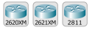

* **Switch:**

A switch is a multiport bridge with a buffer and a design that can boost its efficiency (many ports imply less traffic) and performance. A switch is a data link layer device. The switch can perform error checking before forwarding data, which makes it particularly effective because it only forwards good packets to the right port and does not transmit packets with problems.

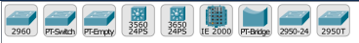

* The Cisco® Catalyst® 2960 Series is a family of fixed- configuration, standalone switches that provide Fast Ethernet and Gigabit Ethernet connectivity and support enhanced switching services, advanced security, IP communications, wireless networking, and scalable management.
* The Cisco Catalyst 2950 Series is a line of fixed-configuration, stackable, and standalone switches that provide wire-speed Fast Ethernet and Gigabit Ethernet connectivity.
* The Cisco® Catalyst® 3560 Series is a line of fixed-configuration, enterprise-class switches that include IEEE 802.3af and Cisco prestandard Power over Ethernet (PoE) functionality in Fast Ethernet and Gigabit Ethernet configurations.
* **Hub:**

In essence, a hub is a multi-port repeater. A hub joins several wires that come from several branches, like the connector in a star topology that joins various stations. Data packets are delivered to all connected devices since hubs are unable to filter data. In other words, all hosts connected by Hub continue to share a single collision domain. Additionally, they lack the intelligence to choose the best route for data packets, which results in waste and inefficiency.

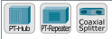

* **End Devices:**

An end device is either the source or destination of a message transmitted over the network.

* Computers (workstations, laptops, file servers, and web servers)
* Network printers
* VoIP phones
* TelePresence endpoints
* Security cameras
* Mobile handheld devices



**Result:**

Successfully studied about all the devices.

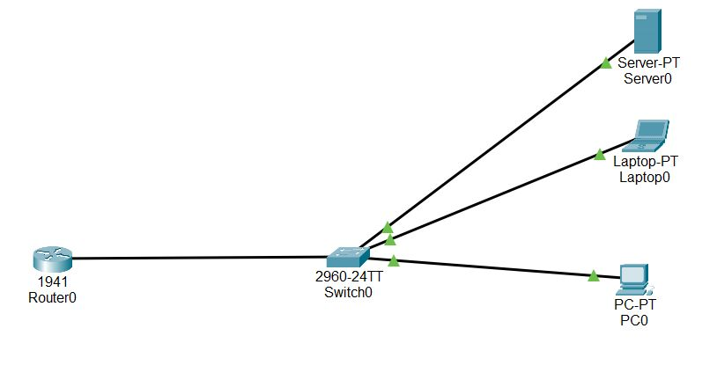**Today’s Lab Work:**

**Evaluation Table: -**

|  |  |  |  |
| --- | --- | --- | --- |
| **Criteria** | **Total Marks** | **Marks Obtained** | **Comments** |
| Concept (A) | 2 |  |  |
| Implementation (B) | 2 |  |  |
| Performance (C) | 2 |  |  |
| Total | 6 | | |

**EXPERIMENT-2**

**AIM:**

To Configure initial Switch Settings.

**Devices Used**:

Switches, PCs, and Cable**s**

**Objectives**

Part 1: Verify the Default Switch Configuration

Part 2: Configure a Basic Switch Configuration

Part 3: Configure a MOTD Banner

Part 4: Save Configuration Files to NVRAM

Part 5: Configure S2

Part 1: Verify the Default Switch Configuration

Step 1: Enter privileged EXEC mode.

Step 2: Examine the current switch configuration.

Part 2: Create a Basic Switch Configuration

Step 1: Assign a name to a switch.

Step 2: Secure access to the console line.

Step 3: Verify that console access is secured.

Step 4: Secure privileged mode access.

Step 5: Verify that privileged mode access is secure.

Step 6: Configure an encrypted password to secure access to privileged mode.

Step 7: Verify that the enable secret password is added to the configuration file.

Step 8: Encrypt the enable and console passwords.

**Q.) What is Cisco Enable Secret Password (Encrypted Privileged Exec Password)?**

Ans) The "enable secret" password in Cisco networking refers to the password used to protect access to privileged EXEC mode, which is a higher level of command-line access with more advanced configuration and management capabilities. This password is used to restrict unauthorized users from gaining elevated privileges on Cisco networking devices, such as routers and switches.

**Q.)** **If** you **configure any more passwords on the switch, will they be displayed in the configuration file as plain text**

**or in encrypted form? Explain.**

**Ans)** When we configure additional passwords on a Cisco switch or any other Cisco networking device, the passwords will be stored in the configuration file in encrypted form, not as plain text. This is a security measure to prevent unauthorized access to sensitive information, such as passwords, in case someone gains access to the configuration files.

Part 3: Configure a MOTD Banner

Step 1: Configure a message of the day (MOTD) banner.

Part 4: Save and Verify Configuration Files to NVRAM

Step 1: Verify that the configuration is accurate using the show run command.

**Q.) Why should every switch have a MOTD banner?**

**Ans**) A MOTD banner is a simple yet effective way to enhance the security, communication, and operational aspects of network device management.

Q.) **Which command will display the contents of NVRAM?**

**Ans**) show startup-config

**Q.) When will this banner be displayed?**

**Ans)** It's displayed at points where users are granted access to the device to ensure that they are aware of any relevant information before interacting with the system.

Part 5: Configure S2

**Procedure:**

Open the activity through the Cisco Packet Tracer (2.5.5)

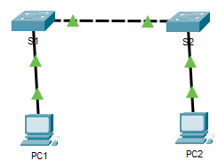

Fig. Diagram Representing connection between devices.

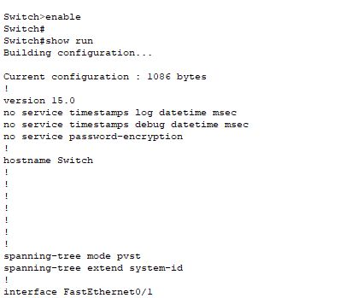 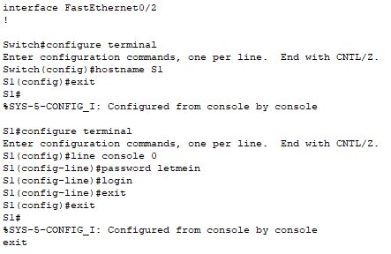

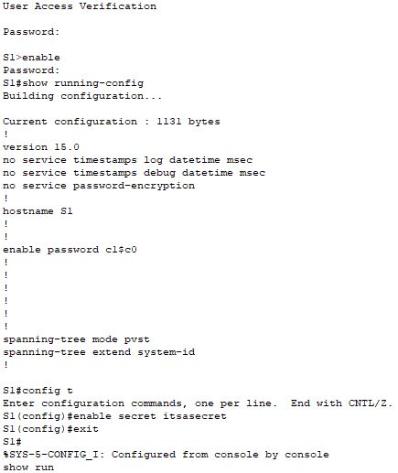 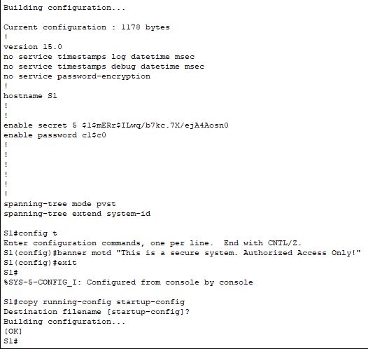

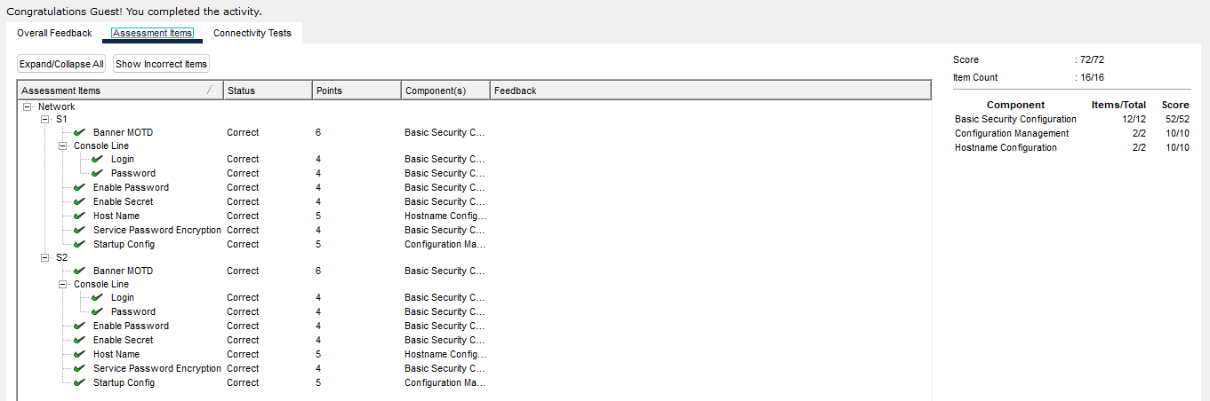**Result:**

**Evaluation Table: -**

|  |  |  |  |
| --- | --- | --- | --- |
| **Criteria** | **Total Marks** | **Marks Obtained** | **Comments** |
| Concept (A) | 2 |  |  |
| Implementation (B) | 2 |  |  |
| Performance (C) | 2 |  |  |
| Total | 6 | | |

**EXPERIMENT-3**

**AIM:**

To implement basic connectivity.

**Devices Used**:

Switches, PCs, and Cable**s**

**Objectives**

Part 1: Perform a Basic Configuration on S1 and S2

Part 2: Configure the PCs

Part 3: Configure the Switch Management Interface

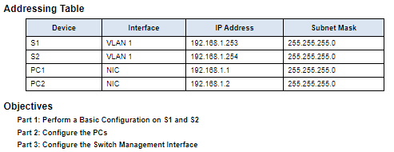

Fig. Addressing Table

Part 1: Perform a Basic Configuration on S1 and S2

Step 1: Configure S1 with a hostname. Step 2: Configure the console and encrypted privileged EXEC mode passwords.

Step 3: Verify the password configurations for S1.

Step 4: Configure an MOTD banner.

Step 5: Save the configuration file to NVRAM.

Step 6: Repeat Steps 1 to 5 for S2.

Part 2: Configure the PCs

Step 1: Configure both PCs with IP addresses.

Step 2: Test connectivity to switches.

Part 3: Configure the Switch Management Interface

Step 1: Configure S1 with an IP address.

Step 2: Configure S2 with an IP address.

Step 3: Verify the IP address configuration on S1 and S2.

Step 4: Save configurations for S1 and S2 to NVRAM.

Step 5: Verify network connectivity.

**Q.) Which command do you issue to accomplish this step?**

**Ans)** copy running-config startup-config

**Q.) Why do you enter the no shutdown command?**

**Ans)** The no shutdown command is used within the interface configuration mode to enable the interface "GigabitEthernet0/1".

**Procedure:**

Open the activity through the Cisco Packet Tracer (2.7.6)

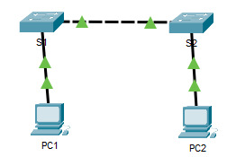

Fig. Diagram Representing Connection Between Devices

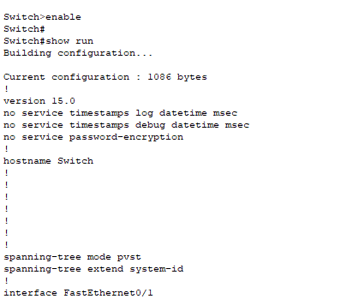 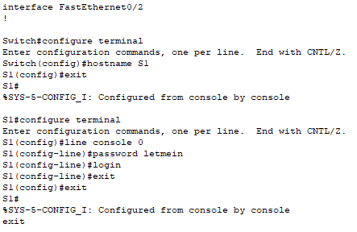

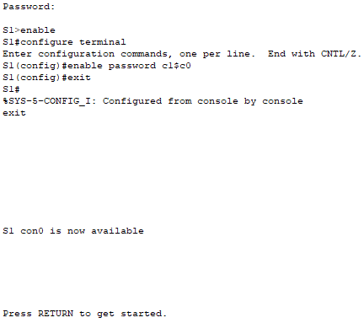 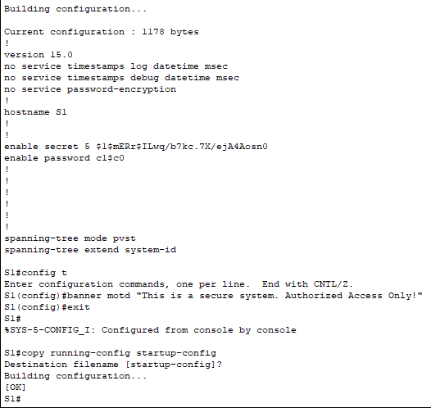

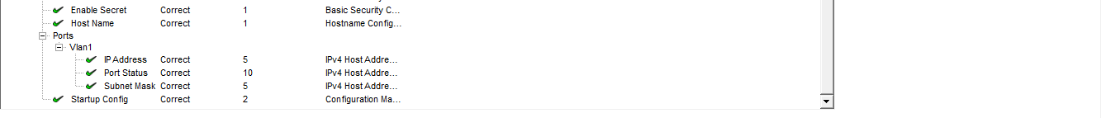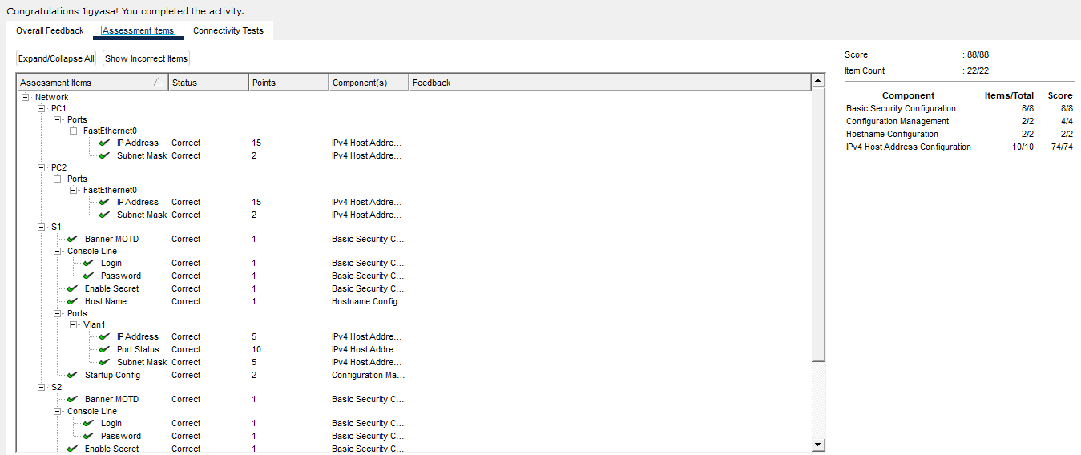**Result:**

**Evaluation Table: -**

|  |  |  |  |
| --- | --- | --- | --- |
| **Criteria** | **Total Marks** | **Marks Obtained** | **Comments** |
| Concept (A) | 2 |  |  |
| Implementation (B) | 2 |  |  |
| Performance (C) | 2 |  |  |
| Total | 6 | | |

**EXPERIMENT-4**

**AIM:**

Basic switch and end device configuration.

**Devices Used**:

Switches, PCs, and Cable**s.**

**Objectives**

Part 1: Set Up the Network Topology

Part 2: Configure PC Hosts

Part 3: Configure and Verify Basic Switch Settings

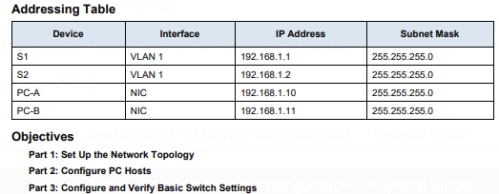

Fig. Addressing Table

**Q.) Why are some FastEthernet ports on the switches up while others are down?**

Ans) The state of a port depends on various factors, and here are some common reasons why some FastEthernet ports might be up while others are down:

* Administrative Shutdown: If a FastEthernet port is in a "down" state, it might have been intentionally administratively shut down using the shutdown command in the interface configuration.
* Configuration Errors: Configuration errors, such as incorrect IP addressing, VLAN assignment, or security settings, can result in an interface being down. Misconfigured interfaces might not be able to establish a valid link, leading to the "down" state.
* Cable or Hardware Issues: Physical problems, such as faulty cables, damaged connectors, or hardware issues, can prevent an interface from establishing a link with the connected device. This can cause the port to remain in a "down" state.
* Link Status: The link status of an interface depends on whether a valid link has been established with the connected device. If the connected device (like another switch, router, or computer) is powered off, its interface might not be able to establish a link, resulting in the "down" state.
* Speed and Duplex Mismatch: If the speed and duplex settings of two connected interfaces do not match, it can lead to connectivity issues and cause the interface to remain down.
* STP (Spanning Tree Protocol) Blocking: In a redundant network topology, STP might temporarily block certain interfaces to prevent loops. These blocked interfaces will be in a "down" state until they are unblocked by the STP protocol.
* Auto-negotiation Issues: Auto-negotiation, which allows devices to automatically determine the best link settings, can sometimes fail. This can result in an interface being down if the auto-negotiation process is not successful.

**Q.) What could prevent a ping from being sent between the PCs?**

**Ans)** Given below are few reasons that could prevent a ping from being sent between the two PCs :

* Network Connectivity Issues
* IP Address Conflicts
* Incorrect Subnet Mask
* Firewall Settings
* Switch or Router Configuration
* Routing and Gateway Issues
* Network Load or Congestion
* Remote PC Settings

**Procedure:**

Open the activity through the Cisco Packet Tracer (2.9.2)

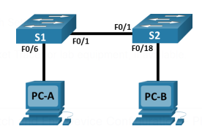

Fig. Diagram representing connection between devices.

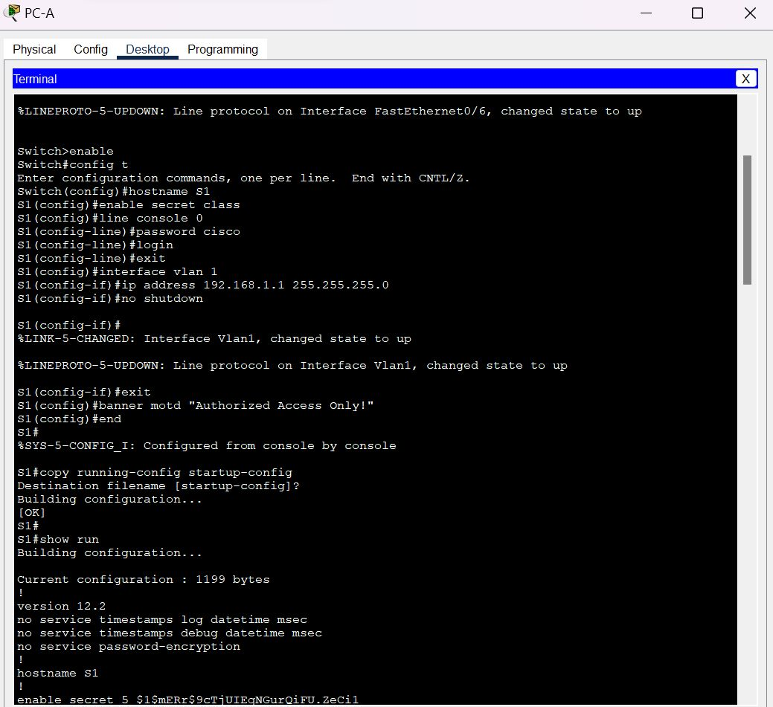 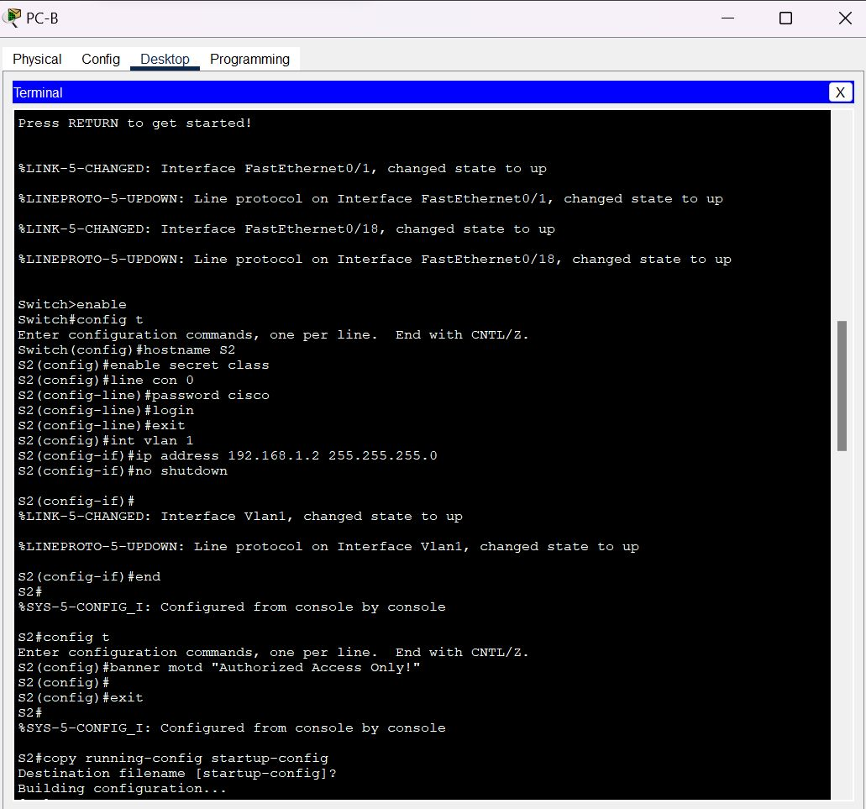

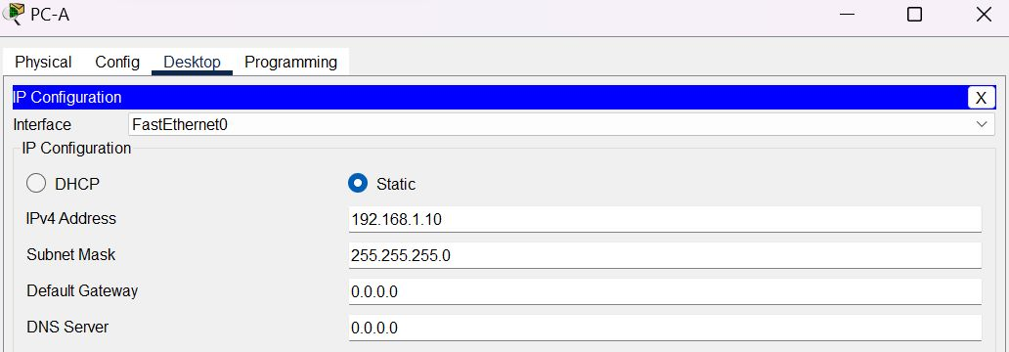

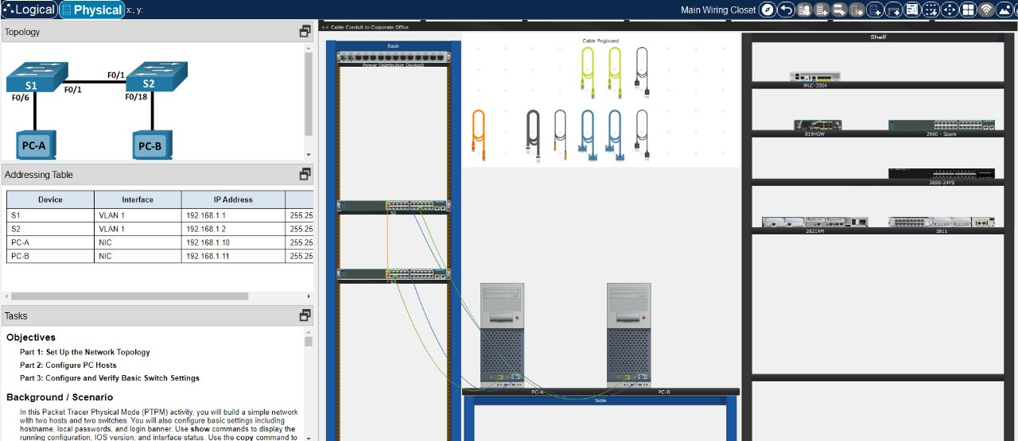

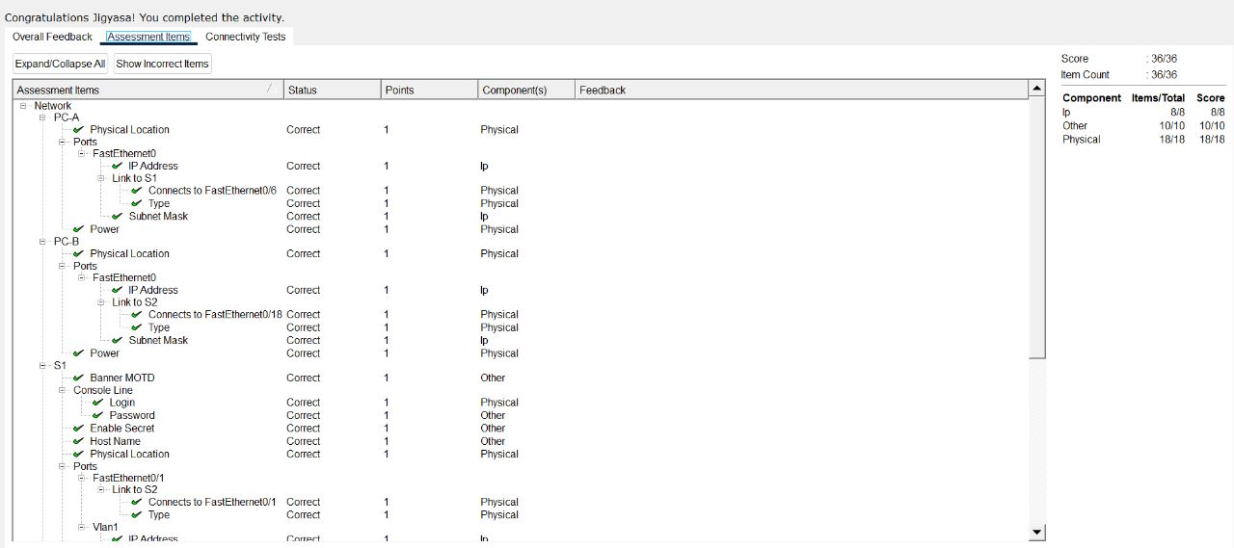**Result**:

**Evaluation Table: -**

|  |  |  |  |
| --- | --- | --- | --- |
| **Criteria** | **Total Marks** | **Marks Obtained** | **Comments** |
| Concept (A) | 2 |  |  |
| Implementation (B) | 2 |  |  |
| Performance (C) | 2 |  |  |
| Total | 6 | | |
|  |  | | |

**EXPERIMENT-5**

**AIM:**

To connect the physical layer.

**Devices Used**:

Switches, PCs, and Cable**s**

**Objectives**

Part 1: Identify Physical Characteristics of Internetworking Devices

Part 2: Select Correct Modules for Connectivity

Part 3: Connect Devices

Part 4: Check Connectivity

Part 1: Identify Physical Characteristics of Internetworking Devices

Step 1: Identify the management ports of a Cisco router.

Step 2: Identify the LAN and WAN interfaces of a Cisco router.

Step 3: Identify module expansion slots.

Part 2: Select Correct Modules for Connectivity

Step 1: Determine which modules provide the required connectivity.

Step 2: Add the correct modules and power up devices.

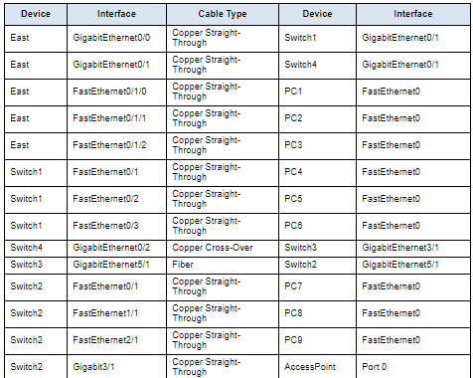Part 3: Connect Devices

Fig. Reference Table for connecting devices.

Part 4: Check Connectivity

Step 1: Check the interface status on East.

Step 2: Connect wireless devices, Laptop and TabletPC

Step 3: Change the access method of the TabletPC.

Step 4: Check connectivity of the other PCs.

**Q.) Which management ports are available?**

Ans) AUX and console ports are available.

**Q.) Which LAN and WAN interfaces are available on the East router and how many are there?**

Ans) There are 2 WAN interfaces and 2 Gigabit Ethernet interfaces.

**Q.) How many physical interfaces are listed?**

Ans) 4

**Q.) What is the default bandwidth of this interface?**

Ans) 1000000 Kbit

**Q.) Click Switch2. How many expansion slots are available?**

Ans) 5 slots are available.

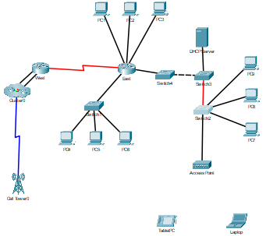

Fig. Diagram with all the connections

**Result**:

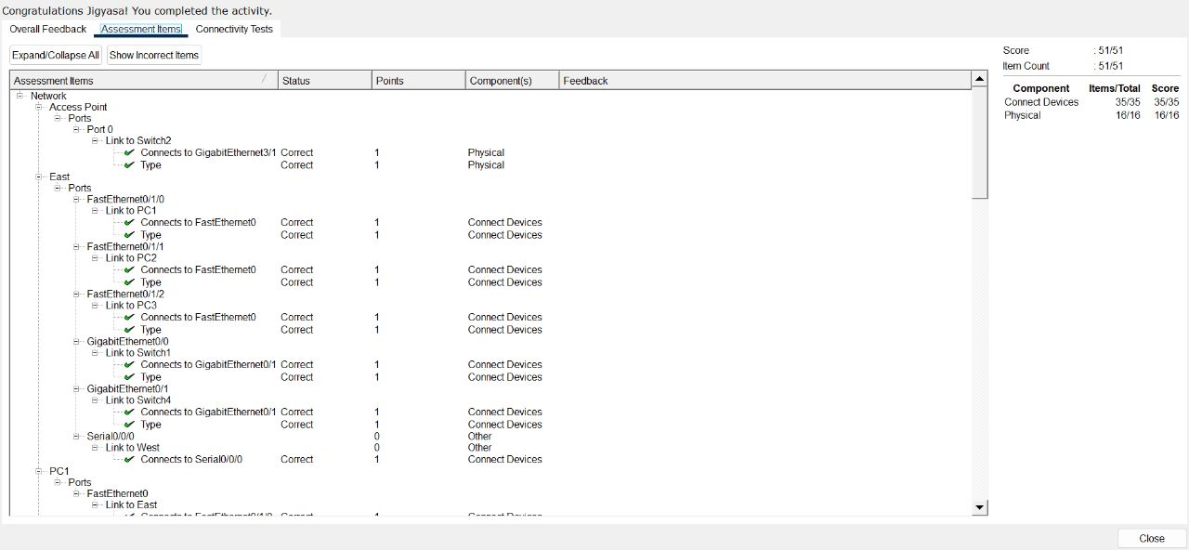

**Evaluation Table: -**

|  |  |  |  |
| --- | --- | --- | --- |
| **Criteria** | **Total Marks** | **Marks Obtained** | **Comments** |
| Concept (A) | 2 |  |  |
| Implementation (B) | 2 |  |  |
| Performance (C) | 2 |  |  |
| Total | 6 | | |

**EXPERIMENT 6**

**AIM:**

To examine ARP Table.

**Software Used**:

Cisco Packet Tracer

**Objectives:**

Part 1: Examine an ARP Request

Part 2: Examine a Switch MAC Address Table

Part 3: Examine the ARP Process in Remote Communications

**Topology**:

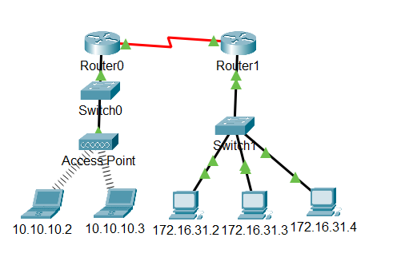

**Addressing Table-**

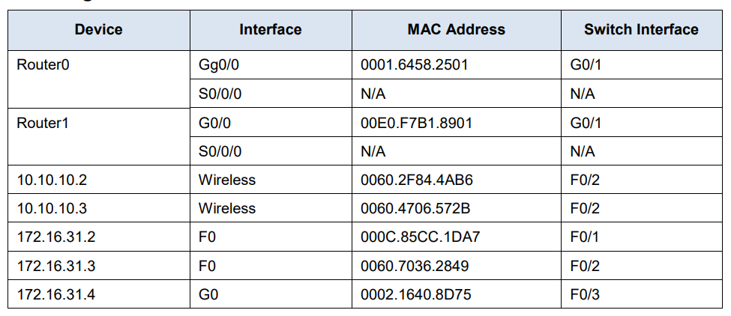

**Questions**:

1. What is the IP address of the device that accepted the PDU?

Ans 172.16.31.3

1. What happened to the source and destination MAC addresses?

Ans Source became destination, FFFF.FFFF.FFFF turned into MAC address of 172.16.31.3

1. How many copies of the PDU did the switch make during the ARP reply?

Ans 1

1. Do the MAC addresses of the source and destination align with their IP addresses?

Ans Yes

1. To what IP address does the MAC address entry correspond?

Ans 172.16.31.3

1. In general, when does an end device issue an ARP request?

Ans When it does not know the receiver’s MAC address.

**Procedure:**

**Part 1**: Examine an ARP Request

Step1: Generate ARP requests by pinging 172.16.31.3 from 172.16.31.2. Open a command prompt a. Click 172.16.31.2 and open the Command Prompt.

b. Enter the arp -d command to clear the ARP table. Close a command prompt

c. Enter Simulation mode and enter the command ping 172.16.31.3. Two PDUs will be generated. The ping command cannot complete the ICMP packet without knowing the MAC address of the destination. So the computer sends an ARP broadcast frame to find the MAC address of the destination.

d. Click Capture/Forward once. The ARP PDU moves Switch1 while the ICMP PDU disappears, waiting for the ARP reply. Open the PDU and record the destination MAC address.

e. Click Capture/Forward to move the PDU to the next device.

f. Open the PDU and examine Layer 2.

g. Click Capture/Forward until the PDU returns to 172.16.31.2.

Step 2: Examine the ARP table.

1. Note that the ICMP packet reappears. Open the PDU and examine the MAC addresses.
2. Switch back to Realtime and the ping completes. c. Click 172.16.31.2 and enter the arp –a command

**Part 2:** Examine a Switch MAC Address Table

Step 1: Generate additional traffic to populate the switch MAC address table. Open a command prompt .

a. From 172.16.31.2, enter the ping 172.16.31.4 command.

b. Click 10.10.10.2 and open the Command Prompt.

c. Enter the ping 10.10.10.3 command

Step 2: Examine the MAC address table on the switches

1. Click Switch1 and then the CLI tab. Enter the show mac-address-table command.
2. Click Switch0, then the CLI tab. Enter the show mac-address-table command.

**Part 3**: Examine the ARP Process in Remote Communications

Step 1: Generate traffic to produce ARP traffic. Open a command prompt

a. Click 172.16.31.2 and open the Command Prompt.

b. Enter the ping 10.10.10.1 command.

c. Type arp –a

d. Enter arp -d to clear the ARP table and switch to Simulation mode

e. Repeat the ping to 10.10.10.1.

f. Click Capture/Forward. Click the PDU that is now at Switch1.

g. The destination IP address is not 10.10.10.1.

Step 2: Examine the ARP table on Router1.

a. Switch to Realtime mode. Click Router1 and then the CLI tab.

b. Enter privileged EXEC mode and then the show mac-address-table command.

c. Enter the show arp command.

**Result:**

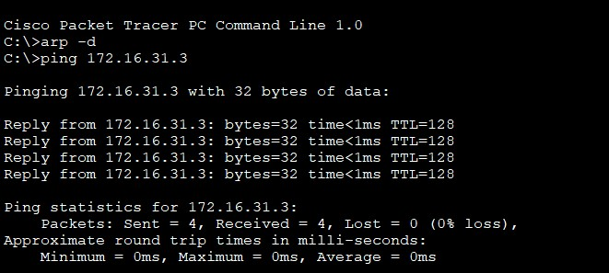

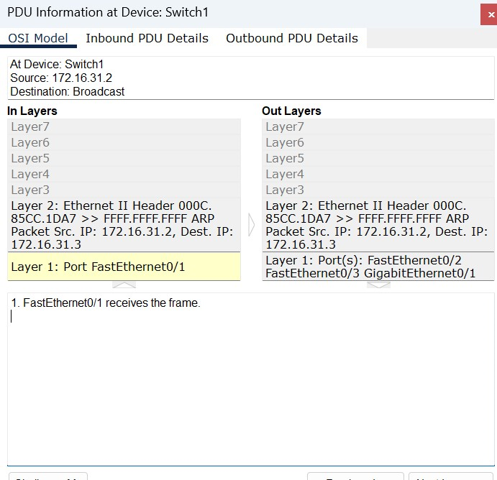

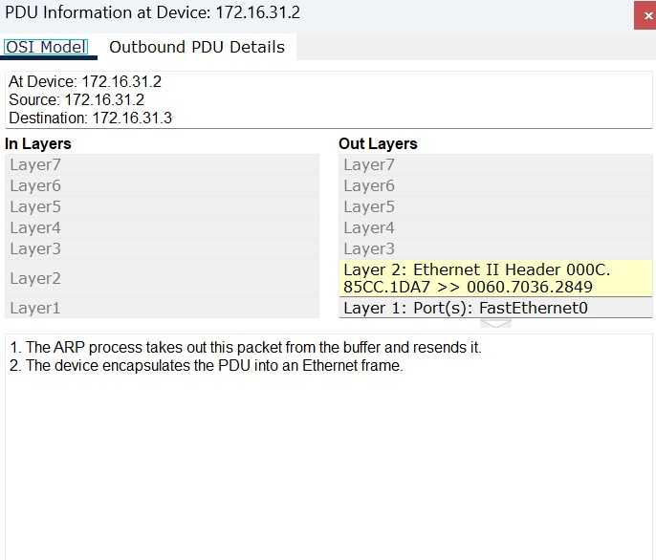

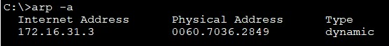

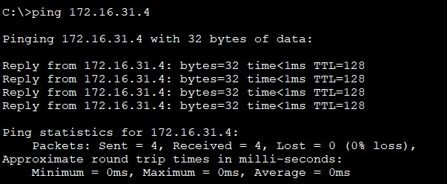

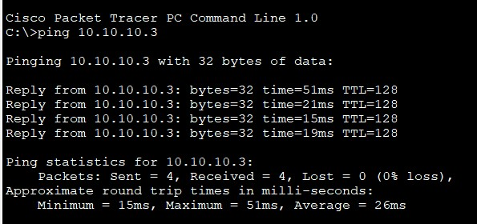

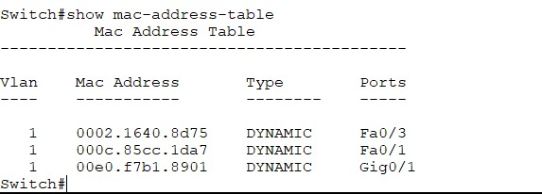

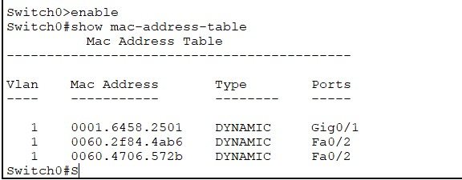

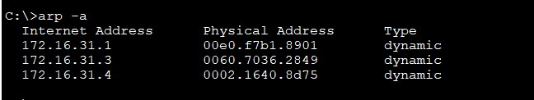

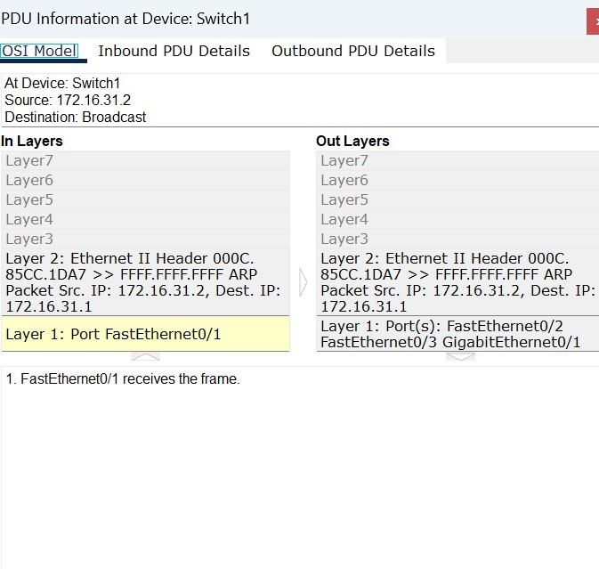

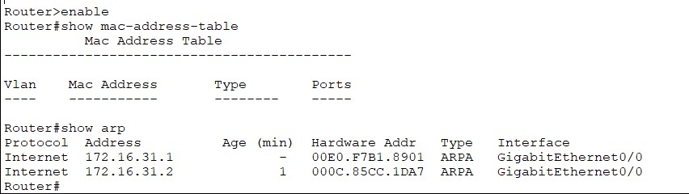

**Evaluation Table:**

|  |  |  |  |
| --- | --- | --- | --- |
| **Criteria** | **Total Marks** | **Marks Obtained** | **Comments** |
| Concept (A) | 2 |  |  |
| Implementation (B) | 2 |  |  |
| Performance (C) | 2 |  |  |
| Total | 6 | | |

**EXPERIMENT 7**

**AIM:**

To View Network Device MAC Addresses.

**Software Used**:

Cisco Packet Tracer

**Objectives**:

Part 1: Configure Devices and Verify Connectivity.

Part 2: Display, Describe, and Analyse Ethernet MAC Addresses.

**Topology**:

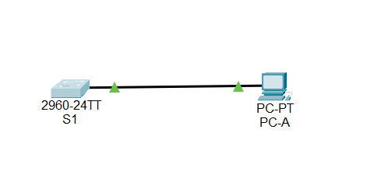

**Addressing Table**:

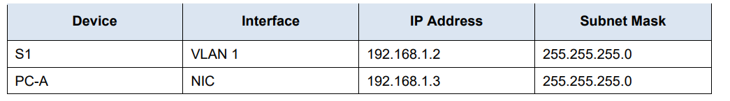

**Questions:**

1. What is the serial number portion of the MAC address for this device?

Ans 24-2A-60

1. What is the MAC address for VLAN 1 on S1?

Ans 001b.0c6d.8f40

1. What is the MAC serial number for VLAN 1?

Ans 6d-8f-40

1. What is the OUI for VLAN 1?

Ans 00-1b-0c

1. Based on this OUI, what is the name of the vendor?

Ans Cisco Systems

1. What does bia stand for?

Ans Burned in address

1. Why does the output show the same MAC address twice?

Ans The MAC address can be changed via a software command. The actual address (bia) will still be there. It is shown in the parenthesis.

1. What Layer 2 addresses are displayed on S1?

Ans S1 VLAN 1 and PC-A MAC addresses.

1. What Layer 3 addresses are displayed on S1?

Ans S1 and PC-A IP addresses.

**Procedure:**

Part 1: Configure Devices and Verify Connectivity In this part, you will set up the network topology and configure basic settings, such as the interface IP addresses and device name. For device name and address information, refer to the Topology and Addressing Table.

Step 1: Cable the network as shown in the topology

a. Attach the devices shown in the topology and cable as necessary.

b. Power on all the devices in the topology.

Step 2: Configure the IPv4 address for the PC

a. Configure the IPv4 address, subnet mask for PC-A.

b. From the command prompt on PC-A, ping the switch address.

Step 3: Configure basic settings for the switch. In this step, you will configure the device name and the IP address, and disable DNS lookup on the switch.

1. Console into the switch and enter global configuration mode.
2. Assign a hostname to the switch based on the Addressing Table.
3. Disable DNS lookup.
4. Configure and enable the SVI interface for VLAN 1.

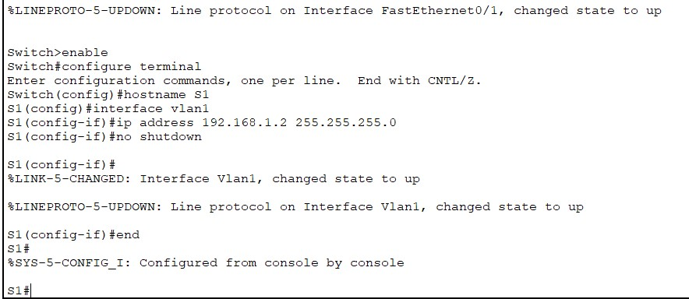

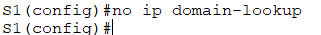

Step 4: Verify network connectivity. Ping the switch from PC-A

Part 2: Display, Describe, and Analyze Ethernet MAC Addresses

Step 1: Analyze the MAC address for the PC-A NIC.

Before you analyze the MAC address on PC-A, look at an example from a different PC NIC. You can issue the ipconfig /all command to view the MAC address of your NIC.

Step 2: Analyze the MAC address for the S1 F0/6 interface. You can use a variety of commands to display MAC addresses on the switch. a. Console into S1 and use the show interfaces vlan 1 command to find the MAC address information. A sample is shown below. Use output generated by your switch to answer the questions.

b. Another way to display the MAC address on the switch is to use the show arp command. Use the show arp command to display MAC address information. This command maps the Layer 2 address to its corresponding Layer 3 address. A sample is shown below. Use output generated by your switch to answer the questions.

Step 3: View the MAC addresses on the switch. Issue the show mac address-table command on S1. A sample is shown below. Use output generated by your switch to answer the questions.

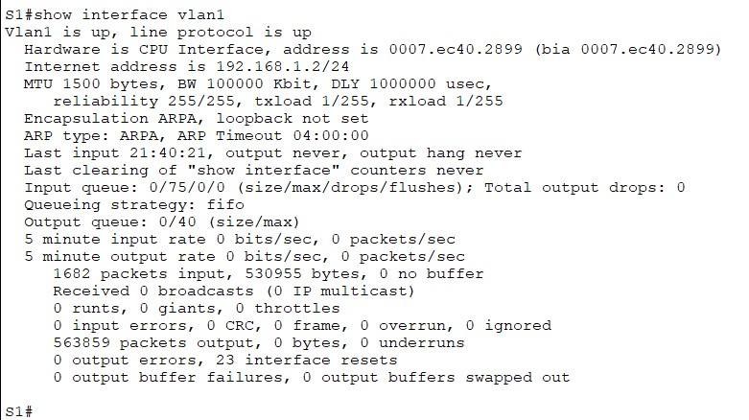

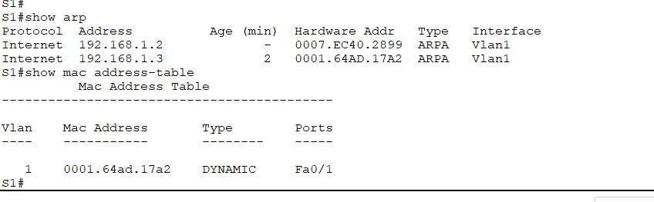

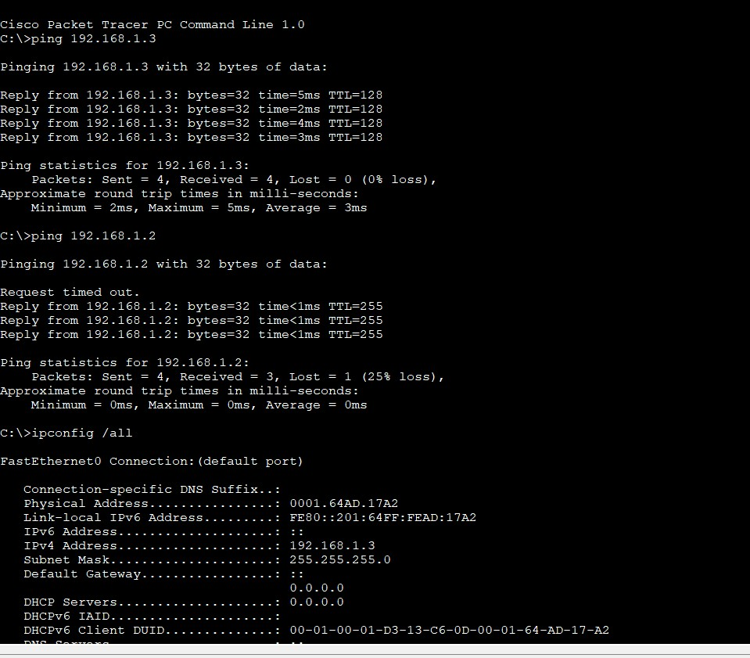

**Result**- Hence, we viewed the Network Device MAC Address.

**Evaluation Table:**

|  |  |  |  |
| --- | --- | --- | --- |
| **Criteria** | **Total Marks** | **Marks Obtained** | **Comments** |
| Concept (A) | 2 |  |  |
| Implementation (B) | 2 |  |  |
| Performance (C) | 2 |  |  |
| Total | 6 | | |

**EXPERIMENT 8**

**AIM:**

To View the Switch MAC Address Table.

**Software Used**:

Cisco Packet Tracer

**Topology**-

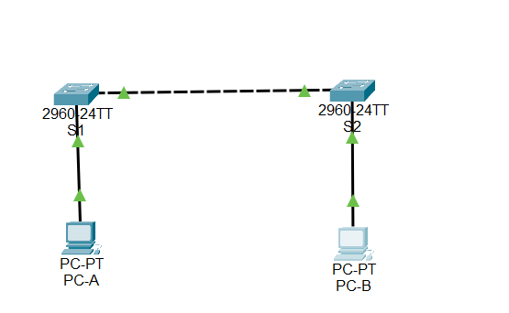

**Addressing Table**-

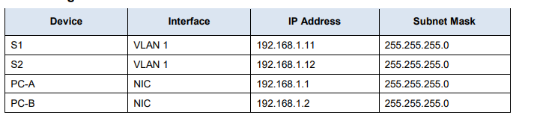

**Objectives**-

**Part 1:** Build and Configure the Network

**Part 2:** Examine the Switch MAC Address Table

**Questions :**

1. What are the Ethernet adapter physical addresses?

Ans PC-A MAC Address- 00-50-56-B3-27-D6

PC-B MAC Address- 00-50-56-B3-FF-54

1. Does the MAC address table have any addresses in it for VLAN 1? Are there other MAC addresses listed?

Ans No, it is discovered that the MAC address for the other switch’s F0/1 switch port has been quickly reinserted in the MAC address table.

1. Are there new addresses in the MAC address table?

Ans Answers will vary .

**Procedure:**

**Part 1: Build and Configure the Network**

Step 1: Cable the network according to the topology.

Step 2: Configure PC hosts.

Step 3: Initialize and reload switches as necessary.

Step 4: Configure basic settings for each switch.

a. Configure device name as shown in the topology.

b. Configure IP address as listed in Addressing Table.

c. Assign cisco as the console and vty passwords.

d. Assign class as the privileged EXEC password.

**Part 2: Examine the Switch MAC Address Table** A switch learns MAC addresses and builds the MAC address table, as network devices initiate communication on the network.

Step 1: Record network device MAC addresses.

a. Open a command prompt on PC-A and PC-B and type ipconfig /all.

b. Console into switch S1 and S2 and type the show interface F0/1 command on each switch.

Step 2: Display the switch MAC address table. Console into switch S2 and view the MAC address table, both before and after running network communication tests with ping.

a. Establish a console connection to S2 and enter privileged EXEC mode. Open a configuration window.

b. In privileged EXEC mode, type the show mac address-table command and press Enter.

Step 3: Clear the S2 MAC address table and display the MAC address table again

a. In privileged EXEC mode, type the clear mac address-table dynamic command and press Enter. S2# clear mac address-table dynamic

b. Quickly type the show mac address-table command again.

Step 4: From PC-B, ping the devices on the network and observe the switch MAC address table. a. From PC-B, open a command prompt and type arp -a.

b. From the PC-B command prompt, ping PC-A, S1, and S2.

c. From a console connection to S2, enter the show mac address-table command.

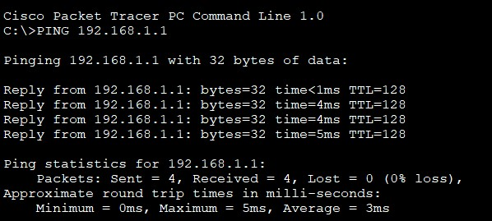

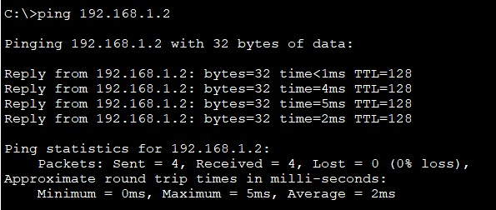

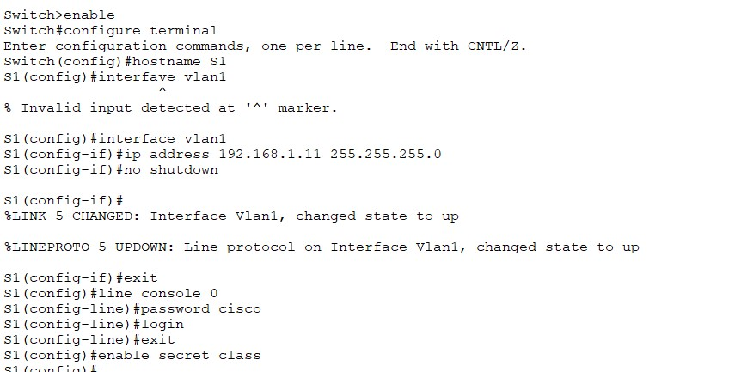

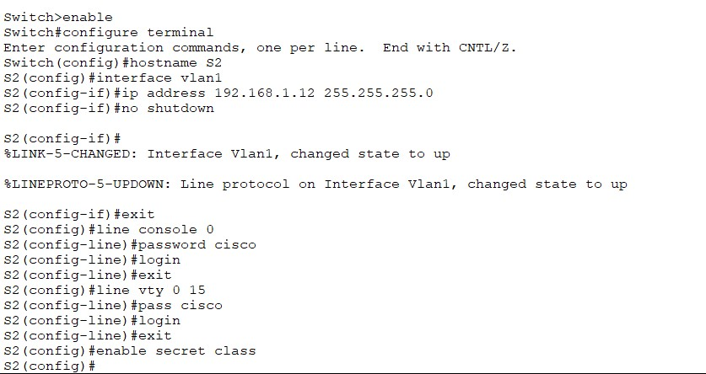

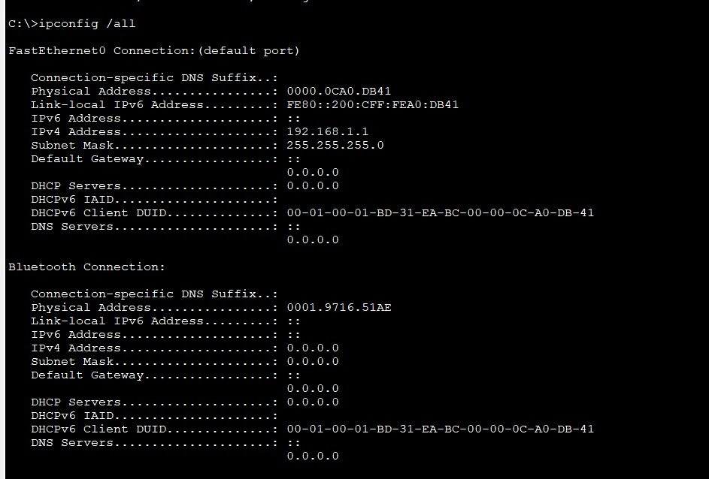

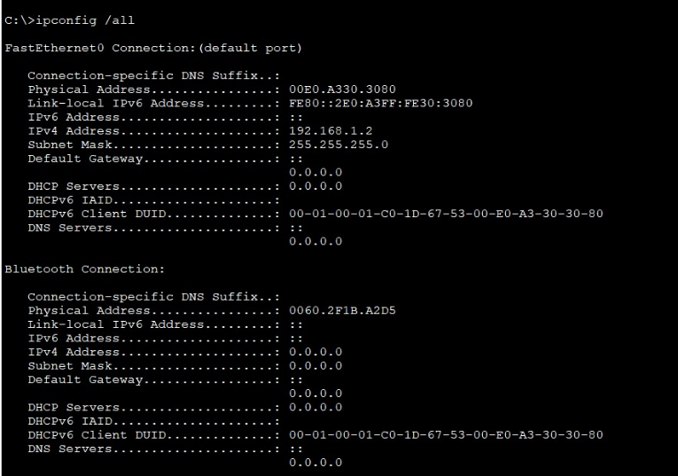

Result- Hence, we viewed the Switch MAC Address Table.

**Evaluation Table: -**

|  |  |  |  |
| --- | --- | --- | --- |
| **Criteria** | **Total Marks** | **Marks Obtained** | **Comments** |
| Concept (A) | 2 |  |  |
| Implementation (B) | 2 |  |  |
| Performance (C) | 2 |  |  |
| Total | 6 | | |

**EXPERIMENT 9**

**Aim:**

To perform basic and initial router configuration

**Devices Used**:

Router, PCs, and Console Cable.

# Objectives:

Part 1: Verify the Default Router Configuration

Part 2: Configure and Verify the Initial Router Configuration Part 3: Save the Running Configuration File

# Questions:

**Q) What is the router’s hostname?**

Ans) Router

# Q) How many Fast Ethernet interfaces does the Router have?

Ans) none

# Q) How many Gigabit Ethernet interfaces does the Router have?

Ans) 2

# Q) How many Serial interfaces does the router have?

Ans) 2

# Q) What is the range of values shown for the vty lines?

Ans) 0-4

# Q) What command do you use to verify initial conﬁguration on router?

Ans) show running-config

# Q) Why should every router have a message-of-the-day (MOTD) banner?

Ans) Every router should have a banner to warn unauthorized users that access is prohibited. MOTD Banners can also be used to send messages to network personnel (such as impending system shutdowns or who to contact for access).

# Q) f you are not prompted for a password before reaching the user EXEC prompt, what console line command did you forget to conﬁgure?

Ans) R1(config-line)# login

# Q) If you conﬁgure any more passwords on the router, are they displayed in the conﬁguration ﬁle as plain text or in encrypted form? Explain.

Ans) The service password-encryption command encrypts all current and future passwords.

# Q) What command did you enter to save the conﬁguration to NVRAM?

Ans) copy running-config startup-config

# Q) Which command displays the contents of the NVRAM?

Ans) show startup-configuration or show start

In this activity, you will perform basic router configuration tasks. You will secure access to the CLI and console port using encrypted and plain-text passwords. You will also configure messages for users who are logging into the router. These banners warn unauthorized users that access is prohibited. Finally, you will verify and save your running configuration.

# Topology:

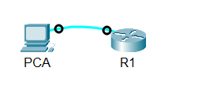

**Procedure**:

**Part 1: Verify the Default Router Configuration**

**Step 1: Establish a console connection to R1**.

Router> enable

Router# show running-config Router# show startup-config Router# configure terminal Router(config) hostname R1

R1(config)# banner motd #Unauthorized access is strictly prohibited# R1(config)#enable password cisco

R1(config)#enable secret itsasecret R1(config)#line console 0 R1(config)#password letmein R1(config)#login

R1(config)#service password-encyrption R1(config)#exit

R1#show running-config

R1#copy running-config startup-config R1# exit

Step 2:Verify the initial router configuration

Verify the initial settings by viewing the configuration for R1. Type your answers here.

b. Exit the current console session until you see the following message:

R1 con0 is now available Press RETURN to get started.

c. Press ENTER; you should see the following message:

Unauthorized access is strictly prohibited. User Access Verification

Password:

**Part 3: Save Running Configuration to NVRAM file**

You have configured the initial settings for R1. Now back up the running configuration file to NVRAM to ensure that the changes made are not lost if the system is rebooted or loses power.

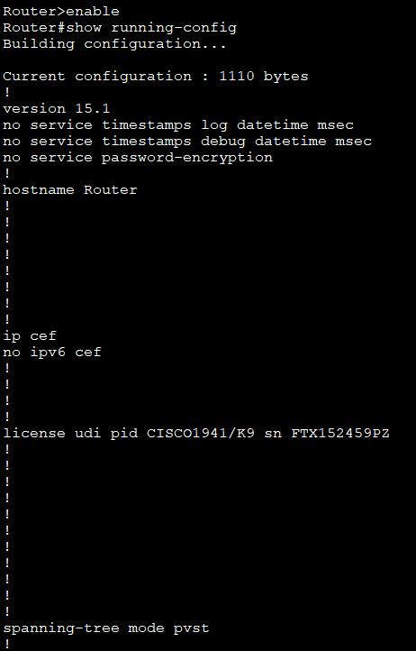

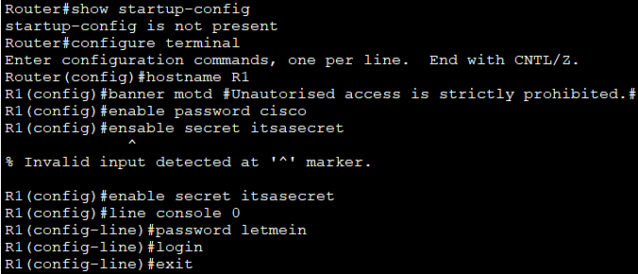

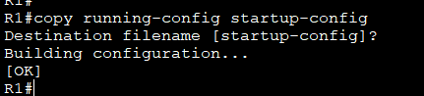

**Result**:

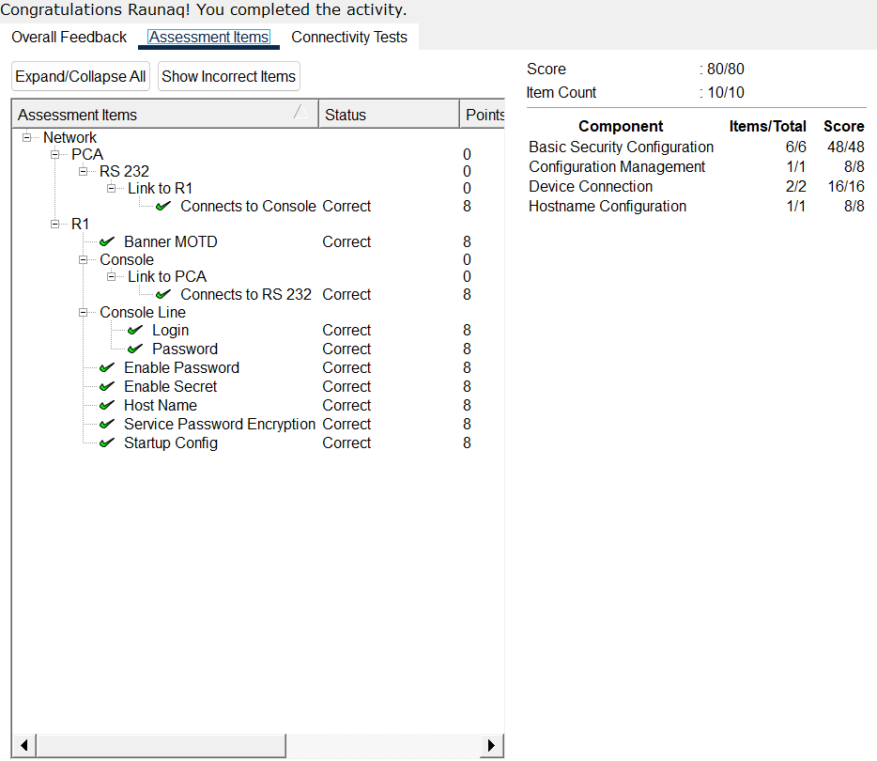

**Evaluation Table: -**

|  |  |  |  |
| --- | --- | --- | --- |
| **Criteria** | **Total Marks** | **Marks Obtained** | **Comments** |
| Concept (A) | 2 |  |  |
| Implementation (B) | 2 |  |  |
| Performance (C) | 2 |  |  |
| Total | 6 | | |

**EXPERIMENT 10**

**AIM:**

To connect a router to a LAN.

**Software Used**:

Cisco Packet Tracer

**Objectives** –

Part 1: Display Router Information

Part 2: Configure Router Interfaces

Part 3: Verify the Configuration

**Topology-**

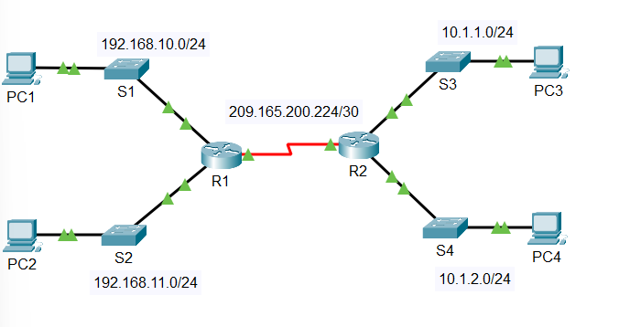

**Addressing Table-**

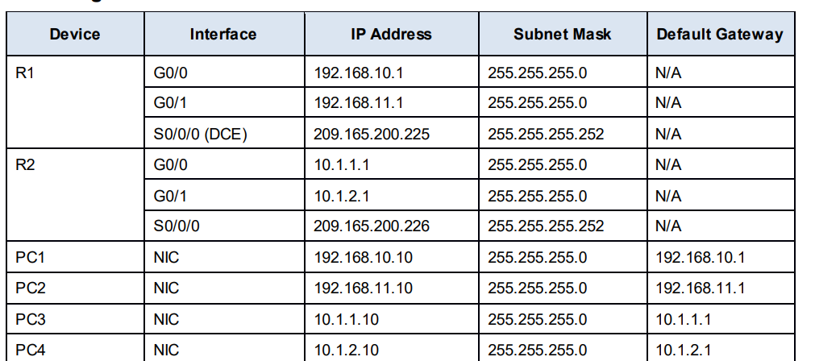

**Questions:**

1. What is the IP address configured on R1?

Ans 209.165.200.225/30

1. What is the bandwidth on the Serial 0/0/0 interface?

Ans 1544 kbits

1. What is the IP address on R1?

Ans There is no IP address configured on the GigabitEthernet 0/0 interface.

1. What is the MAC address of the GigabitEthernet 0/0 interface?

Ans 000d.bd6c.7d01

1. What is the bandwidth on the GigabitEthernet 0/0 interface?

Ans 1000000 kbits

**Part 1: Display Router Information**

Step 1: Display interface information on R1.

Note: Click a device and then click the CLI tab to access the command line directly. The console password is cisco. The privileged EXEC password is class**.**

1. Enter the command to display the statistics for the Serial 0/0/0 interface on R1 .
2. Enter the command to display the statistics for the Gigabit Ethernet 0/0 interface

Step 2: Display a summary list of the interfaces on R1.

Step 3: Display the routing table on R1.

**Part 2: Configure Router Interfaces**

Step 1: Configure the GigabitEthernet 0/0 interface on R1.

1. Enter the following commands to address and activate the GigabitEthernet 0/0 interface on R1:

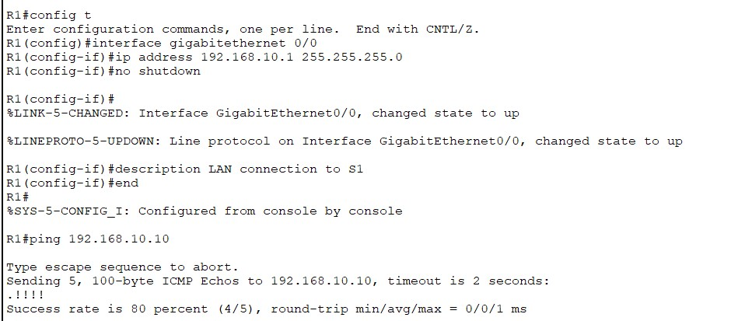

1. It is good practice to configure a description for each interface to help document the network. Configure an interface description that indicates the device to which it is connected.
2. R1 should now be able to ping PC1

Step 2: Configure the remaining Gigabit Ethernet Interfaces on R1 and R2.

a. Use the information in the Addressing Table to finish the interface configurations for R1 and R2. For each interface, do the following:

1) Enter the IP address and activate the interface.

2) Configure an appropriate description.

b. Verify interface configurations.

Step 3: Back up the configurations to NVRAM. Question: Save the configuration files on both routers to NVRAM.

**Part 3: Verify the Configuration**

Step 1: Use verification commands to check your interface configurations.

1. Use the show ip interface brief command on both R1 and R2 to quickly verify that the interfaces are configured with the correct IP address and are active.
2. Use the show ip route command on both R1 and R2 to view the current routing tables.

Step 2: Test end-to-end connectivity across the network.

You should now be able to ping from any PC to any other PC on the network. In addition, you should be able to ping the active interfaces on the routers. For example, the following tests should be successful:

• From the command line on PC1, ping PC4.

• From the command line on R2, ping PC2.

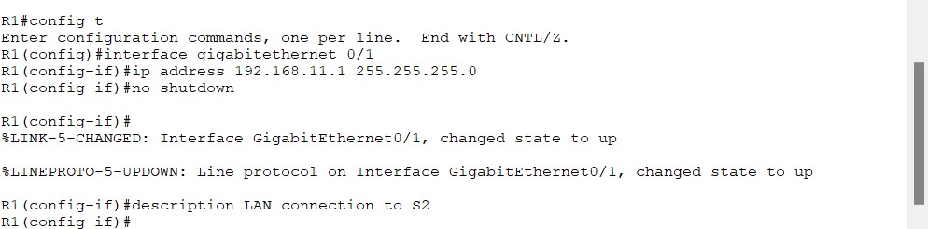

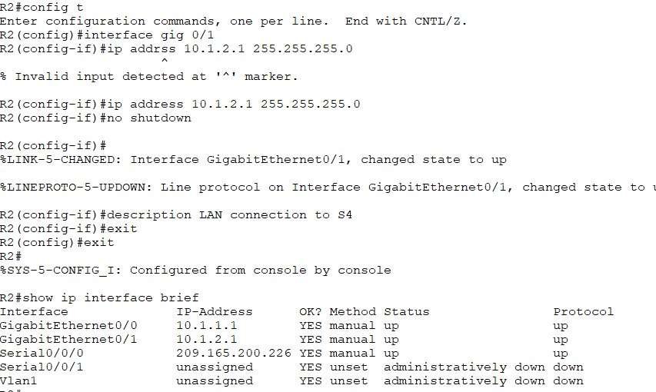

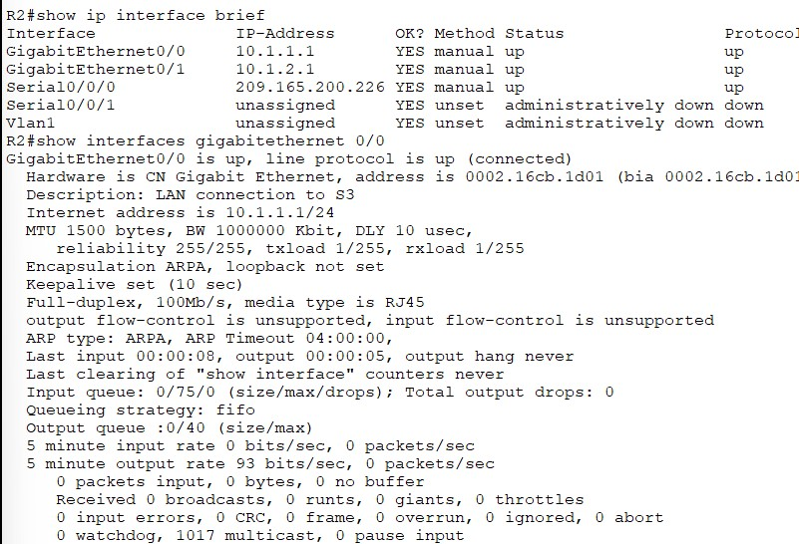

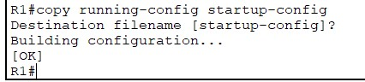

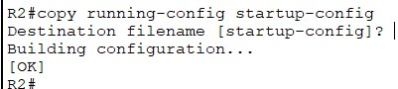

**Result:**

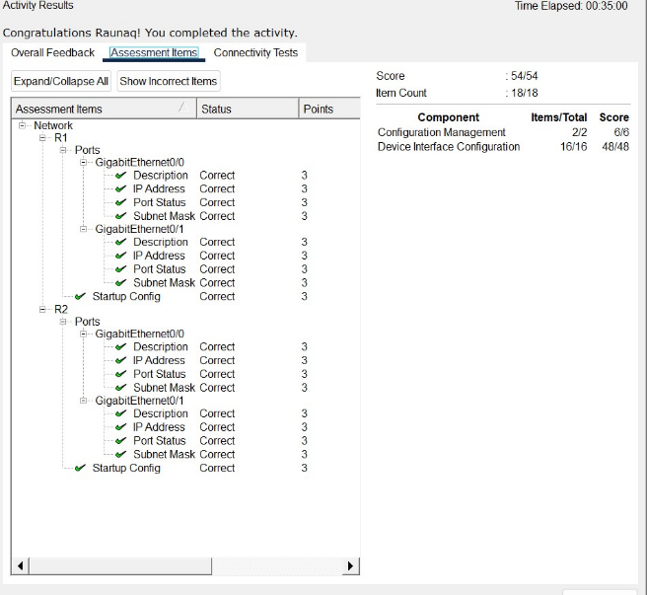

**Evaluation Table: -**

|  |  |  |  |
| --- | --- | --- | --- |
| **Criteria** | **Total Marks** | **Marks Obtained** | **Comments** |
| Concept (A) | 2 |  |  |
| Implementation (B) | 2 |  |  |
| Performance (C) | 2 |  |  |
| Total | 6 | | |

**EXPERIMENT 11**

**Aim:**

Tounderstand the Subnetting Scenario.

**Software Used:** Cisco Packet Tracer

**Topology:**

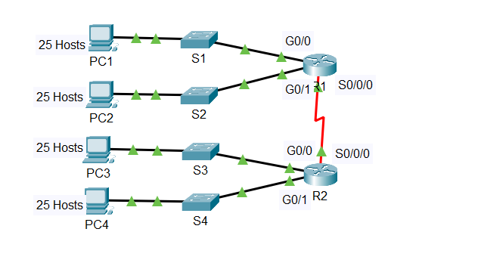

**Objectives:**

Part 1: Design an IP Addressing Scheme

Part 2: Assign IP Addresses to Network Devices and Verify Connectivity

**Questions based on this activity are:**

Q1: Based on the topology, how many subnets are needed?

Ans: 5 Four for the LANS, and one for the link between the routers.

Q2: How many bits must be borrowed to support the number of subnets in the topology table?

Ans: 3

Q3: How many subnets does this create?

Ans: 8

Q4: How many usable hosts does this create per subnet?

Ans: 30

**Addressing Table**-

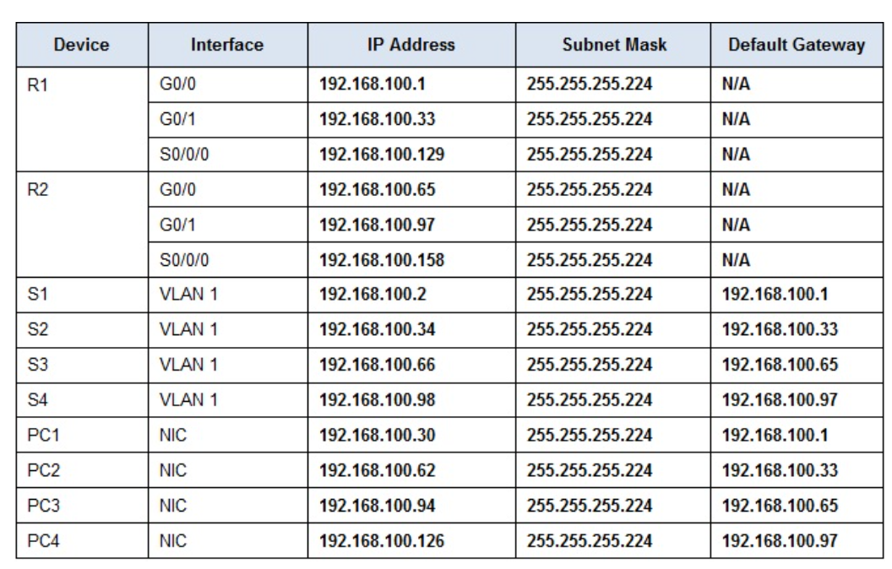

**Part 1: Design an IP Addressing Scheme**

Step 1: Subnet the 192.168.100.0/24 network into the appropriate number of subnets.

**Subnet Table -**

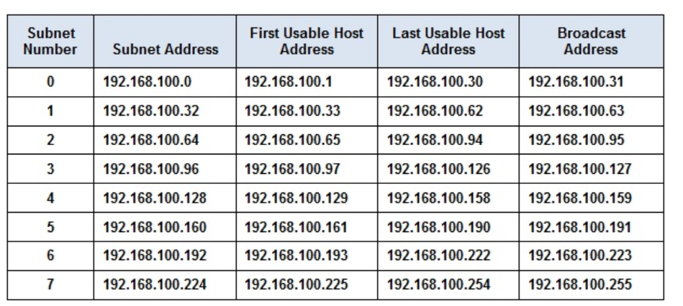

Step 2: Assign the subnets to the network shown in the topology.

Step 3: Document the addressing scheme.

**Part 2: Assign IP Addresses to Network Devices and Verify Connectivity**

Step 1: Configure R1 LAN interfaces.

Step 2: Configure IP addressing on S3.

Step 3: Configure PC4.

Step 4: Verify connectivity.

**Result**-

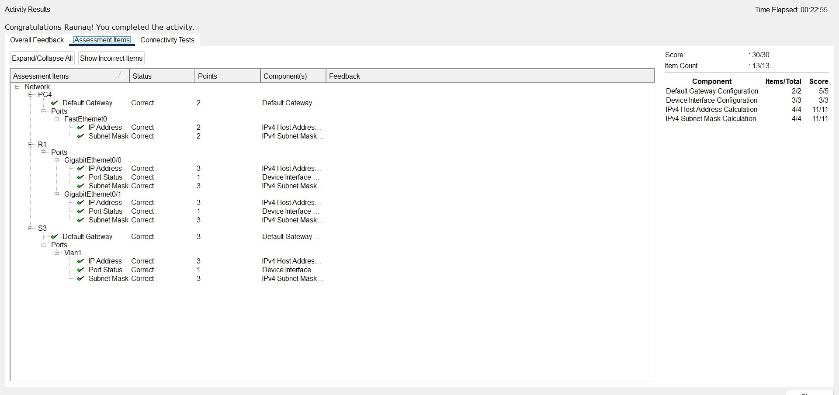

**EXPERIMENT 12**

**Aim:**

To study VLSM Design and Implementation.

**Software Used**:Cisco Packet Tracer

**Topology**:

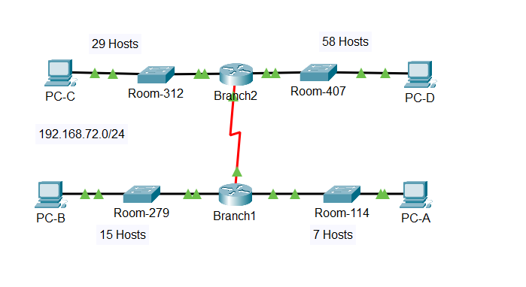

**Objectives-**

Part 1: Examine the Network Requirements

Part 2: Design the VLSM Addressing Scheme

Part 3: Assign IP Addresses to Devices and Verify Connectivity

**Questions related to this activity are:**

Q1: How many subnets are needed in the network topology?

Ans: 5

Q2: Which subnet mask will accommodate the number of IP addresses required for ASW-1?

Ans: 255.255.255.240/24

Q3: How many usable host addresses will this subnet support?

Ans: 14 (10.11.48.97-10.11.48.110)

Q4: Which subnet mask will accommodate the number of IP addresses required for ASW-2?

Ans: 255.255.255.224 /27

Q5: How many usable host addresses will this subnet support?

Ans: 30 (10.11.48.65-10.11.48.94)

Q6: Which subnet mask will accommodate the number of IP addresses required for ASW-3?

Ans: 255.255.255.248/29

Q7: How many usable host addresses will this subnet support?

Ans: 6 (10.11.48.113-10.11.48.118)

Q8: Which subnet mask will accommodate the number of IP addresses required for ASW-4?

Ans: 255.255.255.192/26

Q9: How many usable host addresses will this subnet support?

Ans: 62 (10.11.48.1-10.11.48.62)

Q10: Which subnet mask will accommodate the number of IP addresses required for the connection between Building I and Building??

Ans: 255.255.255.252/30

**Addressing Table**

| **Device** | **Interface** | **Address** | **Subnet Mask** | **Default Gateway** |
| --- | --- | --- | --- | --- |
| Branch 1 | G0/0 | 192.168.72.129 | 255.255.255.240 | N/A |
| G0/1 | 192.168.72.97 | 255.255.255.224 | N/A |
| S0/0/0 | 192.162.72.145 | 255.255.255.252 | N/A |
| Branch2 | G0/0 | 192.168.72.65 | 255.255.255.248 | N/A |
| G0/1 | 192.168.72.1 | 255.255.255.192 | N/A |
| S0/0/0 | 192.168.72.146 | 255.255.255.252 | N/A |
| Room-114 | VLAN 1 | 192.168.72.130 | 255.255.255.240 | 192.168.72.129 |
| Room-279 | VLAN 1 | 192.168.72.96 | 255.255.255.224 | 192.168.72.97 |
| Room-312 | VLAN 1 | 192.168.72.66 | 255.255.255.248 | 192.168.72.65 |
| Room-407 | VLAN 1 | 192.168.72.2 | 255.255.255.192 | 192.168.72.1 |
| PC-A | NIC | 192.168.72.142 | 255.255.255.240 | 192.168.72.129 |
| PC-B | NIC | 192.168.72.126 | 255.255.255.224 | 192.168.72.97 |
| PC-C | NIC | 192.168.72.94 | 255.255.255.248 | 192.168.72.65 |
| PC-D | NIC | 192.168.72.62 | 255.255.255.192 | 192.168l.72.1 |

**Instructions**

**Part 1: Examine the Network Requirements**

Step 1: Determine the number of subnets needed.

You will subnet the network address **192.168.72.0/24**. The network has the following requirements:

·         **Room-114** LAN will require **7** host IP addresses

·         **Room-279** LAN will require **15** host IP addresses

·         **Room-312** LAN will require **29** host IP addresses

·         **Room-407** LAN will require **58** host IP addresses

Step 2: Determine the subnet mask information for each subnet.

**Part 2: Design the VLSM Addressing Scheme**

Step 1: Divide the 192.168.72.0/24 network based on the number of hosts per subnet.

a.     Use the first subnet to accommodate the largest LAN.

b.     Use the second subnet to accommodate the second largest LAN.

c.     Use the third subnet to accommodate the third largestLAN.

d.     Use the fourth subnet to accommodate the fourth largestLAN.

e.     Use the fifth subnet to accommodate the connection between **Branch1**and**Branch2**.

Step 2: Document the VLSM subnets.

Step 3: Document the addressing scheme.

a.     Assign the first usable IP addresses to **Branch1** for the two LAN links and the WAN link.

b.     Assign the first usable IP addresses to **Branch2** for the two LAN links. Assign the last usable IP address for the WAN link.

c.     Assign the second usable IP addresses to the switches.

d.     Assign the last usable IP addresses to the hosts.

**Part 3: Assign IP Addresses to Devices and Verify Connectivity**

Most of the IP addressing is already configured on this network. Implement the following steps to complete the addressing configuration.

Step 1: Configure IP addressing on the Branch1 router LAN interfaces.

Step 2: Configure IP addressing on the Room-312, switch including the default gateway.

Step 3: Configure IP addressing on PC-D, including the default gateway.

Step 4: Verify connectivity.

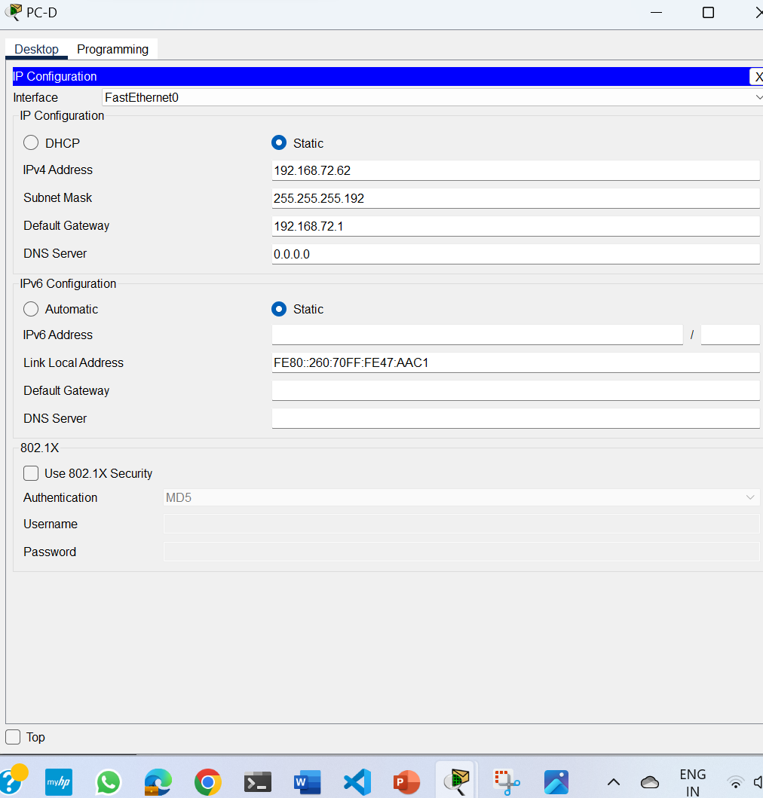

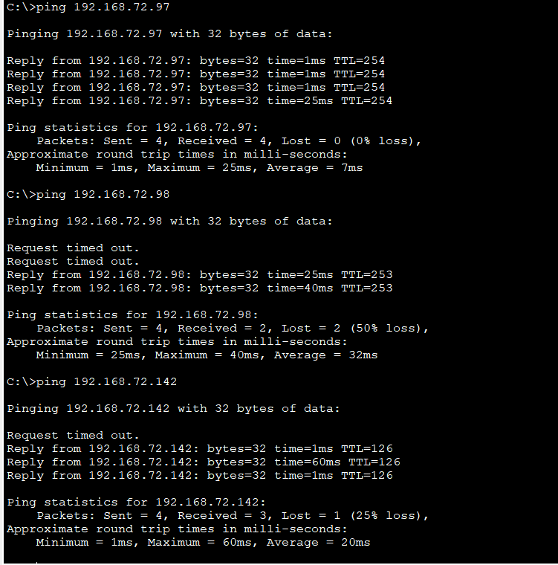

**Result-** Hence we have studied the VLSM Design and Implementation.

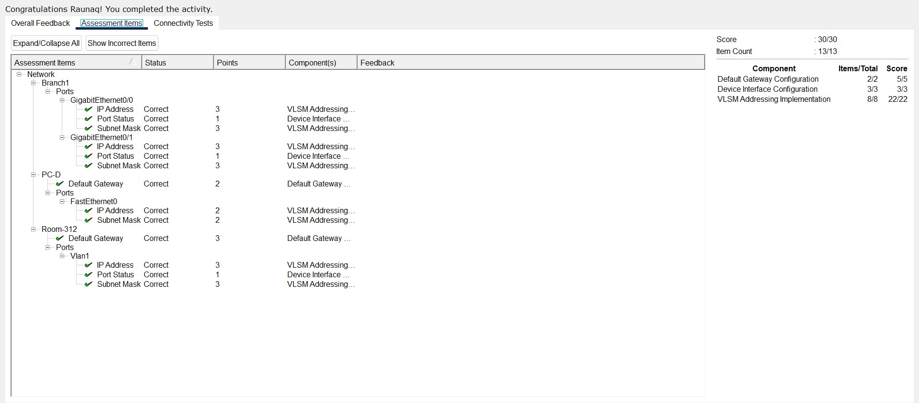



**EXPERIMENT 13**

**Aim**:

To implement a subnetted IPv6 addressing scheme.

**Software Used**:Cisco Packet Tracer

**Topology**:

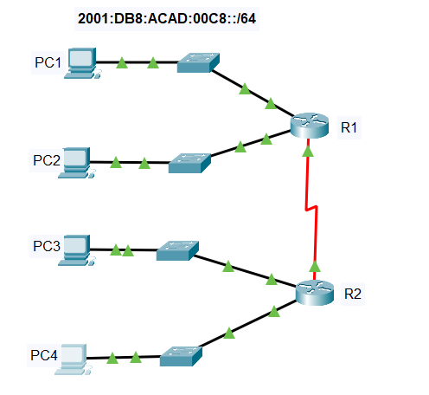

**Addressing Table**-

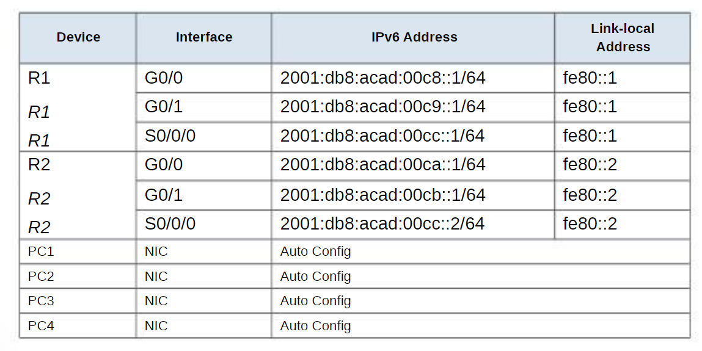

**Objectives-**

Step 1: Determine IPv6 subnets and addressing scheme.

Step 2: Configure IPv6 addressing on routers and PCs.

Step 3: Verify IPv6 connectivity

**Instructions -**

Step 1: Determine IPv6 subnets and addressing scheme.

Step 2: Configure IPv6 addressing on routers and PCs.

Step 3: Verify IPv6 connectivity.

**CLI Mode of R1**-

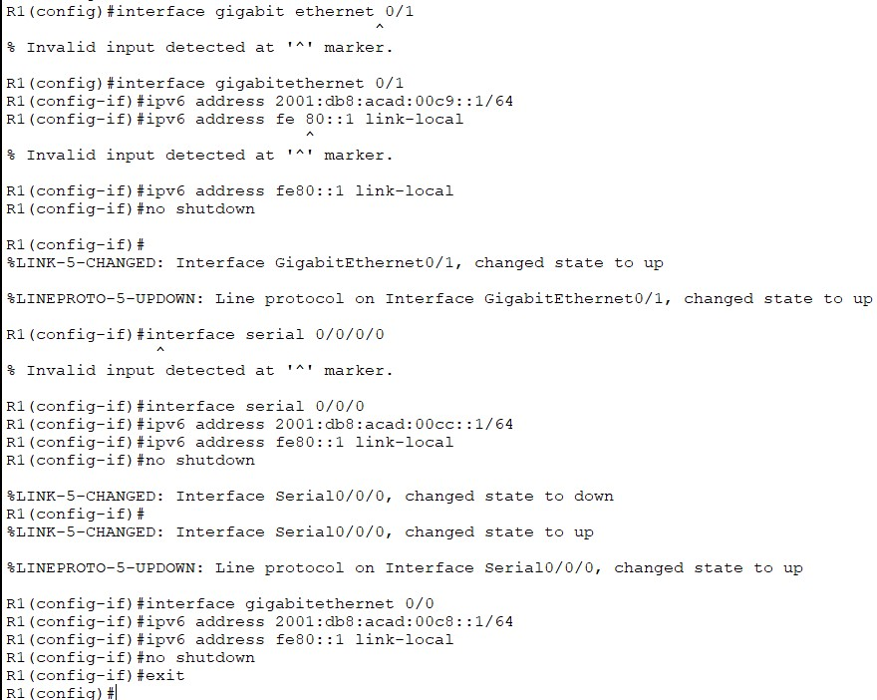

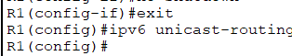

**CLI Mode Of R2-**

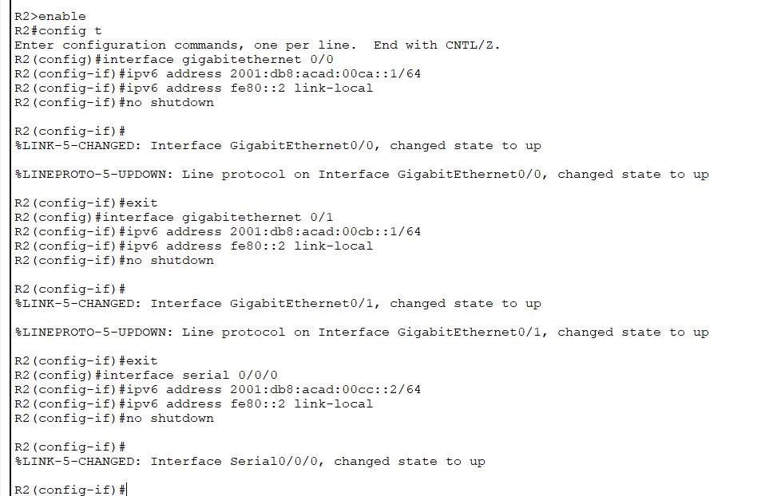 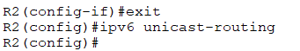

**Result-** Hence we have implemented a subnetted IPv6 Addressing Scheme .

